HC06 Bluetooth Module User Manual

Bluetooth parameters Features:
1.Bluetooth core module using HC-06 from the module, the leading-out interface includes VCC, GND, TXD, RXD, reserved LED state output pin, MCU is connected or not, it should be judged by the foot Bluetooth.
2.LED indicates the status of the bluetooth connection.Flashing indicates no Bluetooth connection, Normally bright means that Bluetooth has been connected and opened the port.
3.Input voltage 3.6-6V, the current is about 30mA when unpaired.when the pairing is about 10mA, the input voltage is forbidden to exceed 7V.
4.It Can be directly connected with a variety of single-chip (51, AVR, PIC, ARM, MSP430, etc.), 5V MCU can also be directly connected.
5.Without bluetooth connection ,it supports through the AT instruction set the baud rate, name, pairing password, save the power off parameter settings. Automatic switch to transmission mode after Bluetooth connection
6.The volume is 3.57cm*1.52cm
7.The Bluetooth is from the machine, from the function with a variety of Bluetooth enabled computers, Bluetooth hosts, most with Bluetooth mobile phones, Android, PDA, PSP and other intelligent terminal pairing, but it can not be paired between the machines.
8.The connection methods of Arduino and Bluetooth Module.

The Connection Methods of Arduino and Bluetooth Module
- VCC：connected to 5V Arduino
2.GND：connected to GND Arduino
3.TXD: sending end, generally expressed as its own sending end,connected to RX Arduino.
4.RXD: receiving end, generally expressed as its own receiving end, connected to TX Arduino.
5.The TXD itself is always connected to the device RXD when it is in the normal communication! RXD to connect to other devices TXD when normal communication.
6.Self-transmitting and receiving system: it receives the data that you send, namely its TXD directly connected to the RXD. It can be used to test the data of sending and receiving is normal or not. It is also the fastest and easiest way to test. So when there was a problem you need to do a test to make sure if the product is faulty. This is also called loop back test.
7.Connected well the cable and powered on Arduino. If the bluetooth indicator light is flashing, indicating that there is no device connection.

As picture, if LED is normal on,it indicates that it has connected well with your Android mobile.
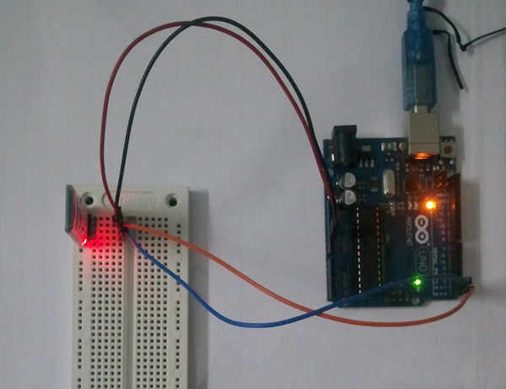
Arduino Debug source code
按 Ctrl+C 复制代码
void setup()
{
Serial.begin(9600);
}

void loop()
{
while(Serial.available())
{
char c=Serial.read();
if(c=='A')
{
Serial.println("Hello I am amarino");
}
}
}
按 Ctrl+C 复制代码
* Copy and paste the source code to IDE,burn the procedure to Arduino
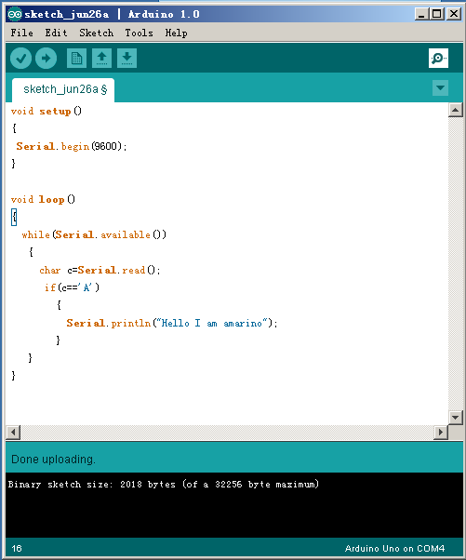
How to connect Arduino bluetooth and Arduino communication
Download the bluetooth management software Amarino of Arduino
You will see Amarino apk file.
Install Armarino,Start Android Bluetooth, and then open the Amarino client

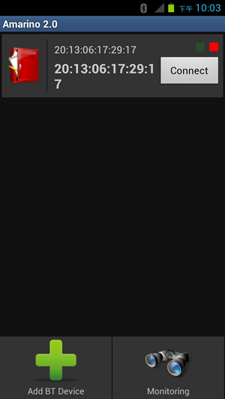
You will find the name of bluetooth on the lower right corner “ADD BT Device”
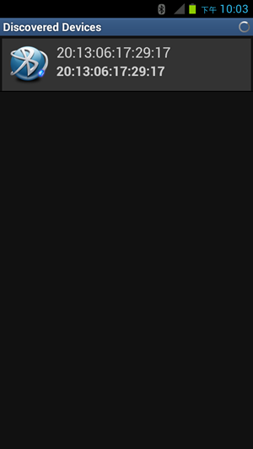
When click “connect”,it will shows PIN bomb box,Bluetooth default PIN 1234(there is no screen shot )
This is the screen shot when connected successfully
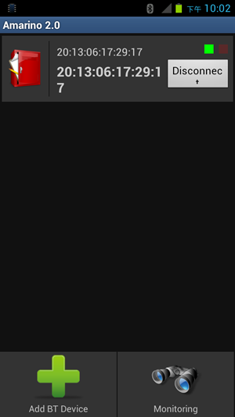
Click “Monitoring”,you can see the bluetooth connected information as follows:
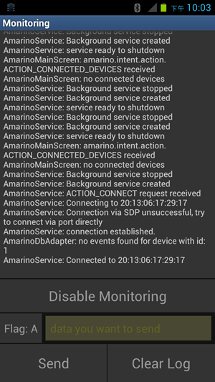
When connected well, we need to see if it is normal when sending datas. So click “send” to check
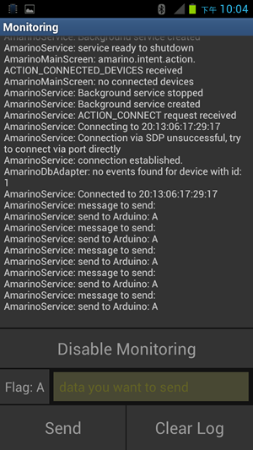
Refer to the Arduino code, when the Arduino receivesall “A” symbols, it will be in the “COM” output corresponding to the content, it shows that the Bluetooth communication is normal as shown.
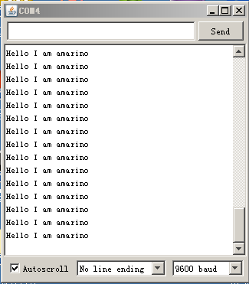
All above is the methods of implementing Arduino Bluetooth module with Arduino communication,hope it
Will help you.

